

Automation Technology 1

Lab 1: Lab Test Kit Introduction and Basic Logic Functions
Lecturer: Eoin Byrne
Submission Date:

Section 1 – Mitsubishi Test Kit Analysis

Instructions:
1: Sketch the complete Mitsubishi FX3G PLC training kit on a full A4 sheet. Include the physical PLC, 24 V DC power supply, toggle switches, input and output devices, HMI, terminal blocks and all associated wiring. Clearly identify the PLC inputs (X), outputs (Y), power supply connections, 0 V/common connections and HMI communication connection. Produce a complete wiring schematic showing how all components of the training kit are interconnected.
(15 Marks)
2: Define the difference between a normally open and normally closed contact and give a brief example where each could be used to perform a logical operation.
(5 Marks)
3: State clearly when troubleshooting potential electrical fault on the test rig using your digital multi-meter, state the very first step that should take place on the test equipment and why.
(5 Marks)

Section 2 – Truth Table Analysis

Abstract:
The aim of this section is to familiarize students with basic logic operations and the programming of simple ladder logic diagrams. Students will download their programs to the Mitsubishi FX PLC, test, and verify the logic functions of six fundamental circuits.

Objective:
To gain practical experience constructing ladder diagrams and programming a PLC using simple logic functions.

Instructions:
- Construct a ladder diagram for each of the circuits shown below. Create a new diagram for each circuit.

- Test the ladder logic to ensure there are no errors or warnings.

- Using truth tables, establish the logic function for each circuit. Use Excel to generate a table for all variables.

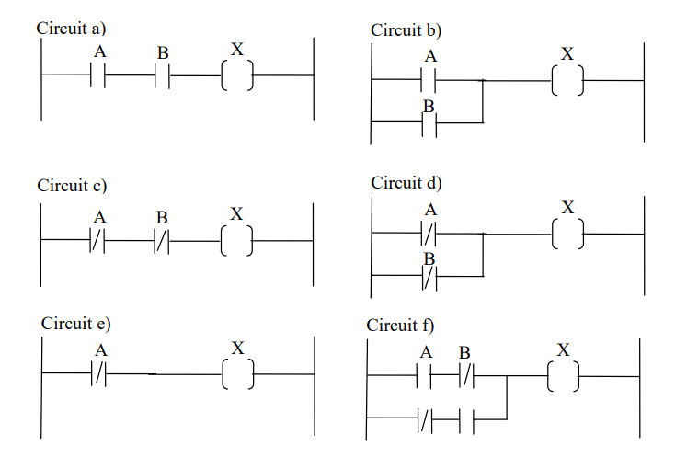
6 Marks Awarded for Each Correct Function
- 2 Marks for Correct Stated Function
- 2 Marks for Correct Truth Table Development
- 2 Marks for Simulated Screen Shot
(Total Marks: 36)

Section 3 – Introduction to Basic Industrial Applications



Basic Automation Problem 1 (32 Marks):
Siemens, a leading motor manufacturer, requires the use of the Mitsubishi FX3 Series PLC in a motor control testing application. The testing apparatus must complete the following sequence of operations:
- On activation of a toggle switch, the 3V motor must engage in a set direction and remain running until the toggle switch is disengaged.
(3 Marks)

- While the motor is running, the green LED on the traffic light control station must be illuminated. (3 Marks)

- When the motor is idle, the red LED on the traffic light control station must be illuminated to indicate that the motor is off. (3 Marks)

- Develop the ladder logic using GX Works, then download it to the PLC test unit provided.

(2 Marks)

- Wire the 3VDC motor using a control relay so that the motor operates with the ladder logic design. Hint: Two different voltages can be used to achieve the required result.

(10 Marks)

- Develop a complete industrial wiring diagram clearly showing how to supply power to the PLC and auxiliaries from a three-phase (415V) supply.
(10 Marks)

- Conclusion and Discussion of results (8 Marks)

